9 SUMMER CONCERT OUTFITS FOR MEN THAT PASS THE VIBE CHECK

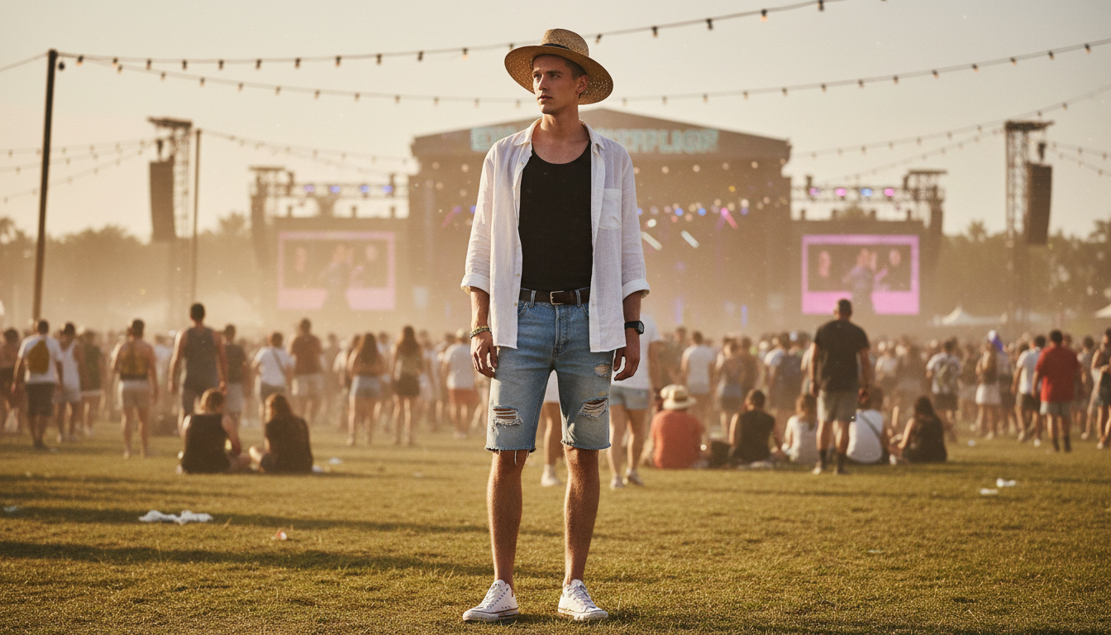

Summer is finally here and that means the music is loud and the weather is hot. You want to look good at the show but you also need to stay comfortable in the heat. Choosing the right look makes the whole experience better. This guide features 9 Summer Concert Outfits for Men That Pass the Vibe Check so you can focus on the music. These looks work for everything from small indie venues to huge outdoor festivals. You can mix and match pieces to fit your own personal style. It is all about feeling confident while you hang out with your friends. Read on to see the best styles for the season.

# Mesh Shirt Summer Concert Outfit

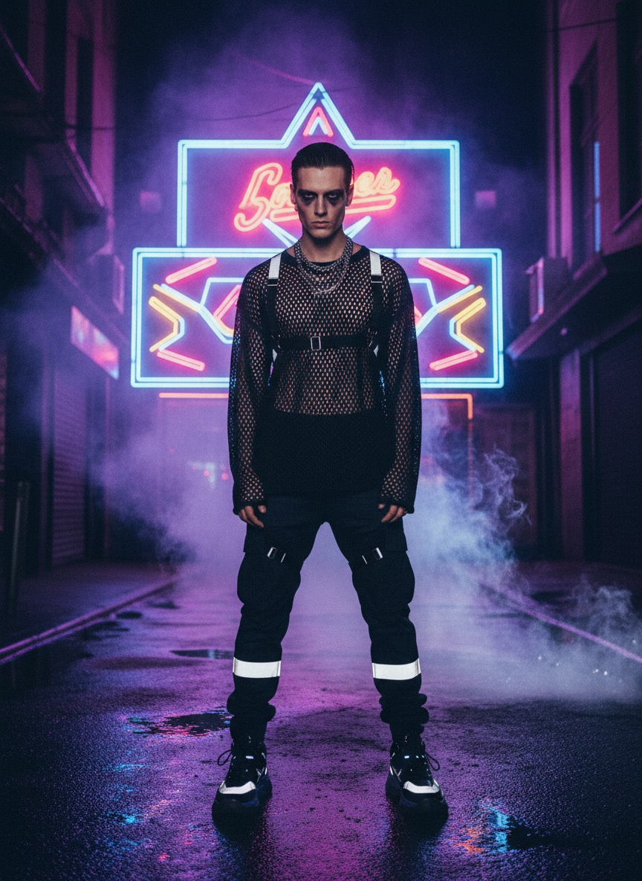

Mesh shirts are the ultimate way to stay cool. Wear a black mesh top with some loose trousers for a dark edgy look. It keeps the air flowing while you dance all night long. Add some silver chains to finish it off. This summer concert outfit is perfect for rave vibes or electronic shows.

# Patterned Button Down Summer Concert Outfit

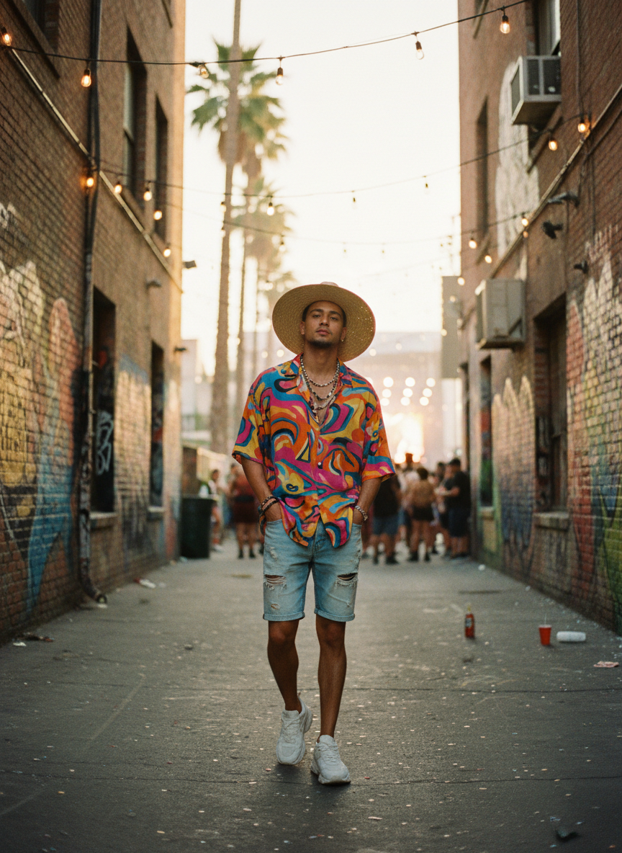

A loud patterned button down is a classic choice for a reason. Keep it unbuttoned over a white tank top for that relaxed look. It feels light and breezy even in a crowded venue. Pair this summer concert outfit with denim shorts. You will look like you just walked off a movie set with this effortless style.

# Graphic Tee Summer Concert Outfit



Nothing beats a vintage graphic tee for a rock show. Look for a faded band shirt or a cool retro design. It shows off your personality without needing extra layers or bulky accessories. Cargo pants are the best match for this summer concert outfit. You will have plenty of pockets for your phone and wallet while you are in the pit.

# Crochet Knit Summer Concert Outfit

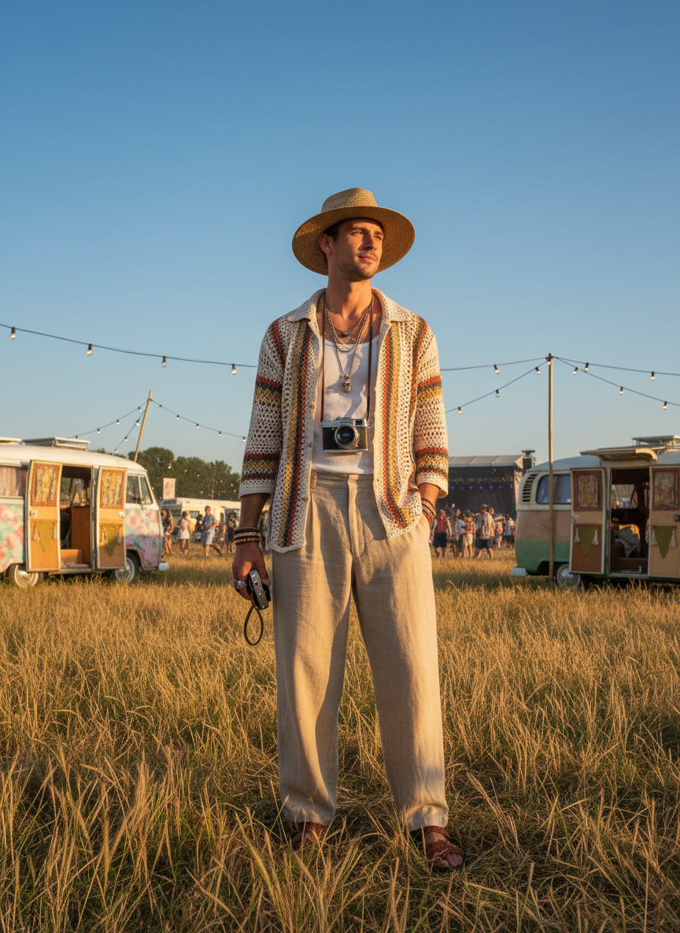

Crochet is massive right now for a reason. A cream crochet shirt looks expensive and stylish at an outdoor festival. It lets the breeze in so you stay chilled while the sun is out. This summer concert outfit works great with linen pants. You will be the best dressed guy in the VIP section with this textured look.

# Sporty Jersey Summer Concert Outfit

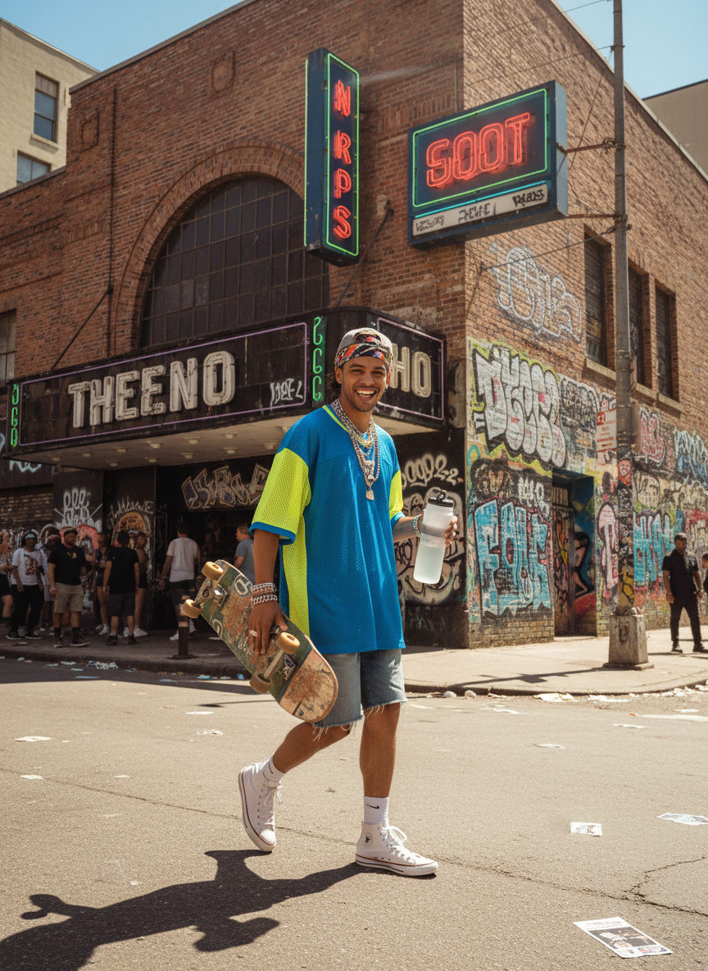

Throw on a vintage soccer or basketball jersey for an athletic feel. Jerseys are made of breathable fabric which is a life saver in the sun. It gives off a high energy vibe that fits any big stadium show. Wear some high socks and clean sneakers. This summer concert outfit is comfortable for standing on your feet for hours.

# Denim on Denim Summer Concert Outfit

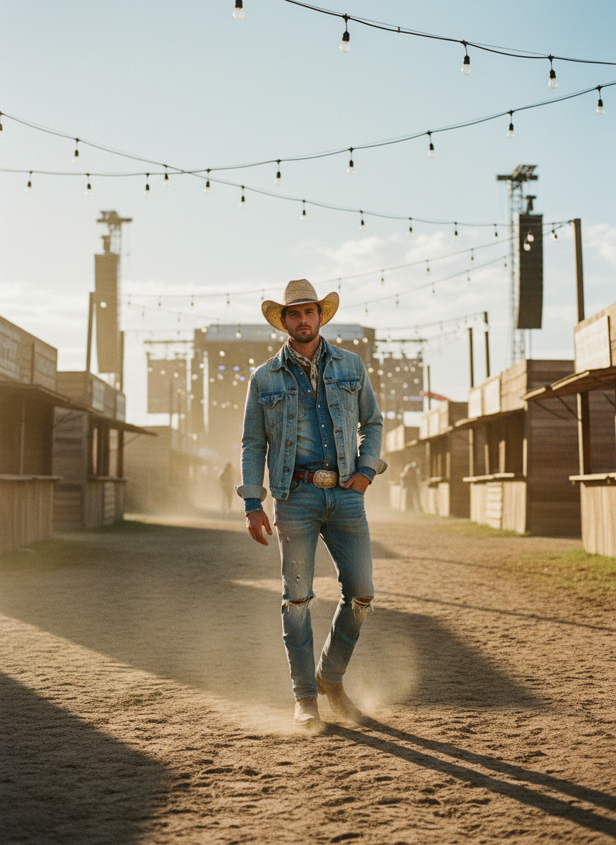

Go for a denim vest or a light wash denim shirt. It gives a rugged feel that works so well for country festivals or outdoor stages. You can leave the vest open if it gets too hot during the day. Match the shades of blue for a cohesive look. This summer concert outfit is a timeless pick that never fails to look cool.

# Matching Set Summer Concert Outfit

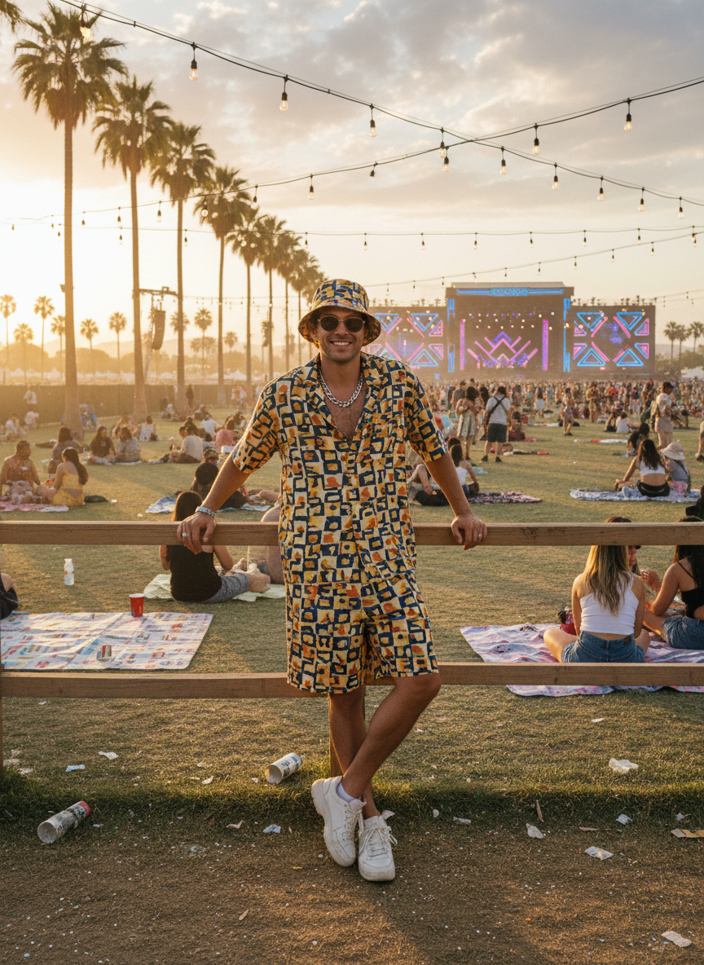

A matching shirt and shorts set takes all the stress out of getting dressed. Pick a bold color like cobalt blue or forest green. It looks intentional and very put together without any effort. You can wear this summer concert outfit with chunky sandals or white leather sneakers. It is the easiest way to look like a fashion icon at a festival.

# Utility Vest Summer Concert Outfit



A utility vest over a basic tee adds so much texture to your look. It has a cool street style edge that stands out in a crowd. Plus you get all those extra pockets for your festival gear and sunglasses. Keep the rest of the look simple with black shorts. This summer concert outfit is practical and stylish at the same time.

# Oversized Linen Summer Concert Outfit



Linen is the king of summer fabrics. An oversized linen button down in a sandy color feels very premium. It looks effortless and stays crisp even if you are sweating in the crowd. Try this summer concert outfit with some relaxed chinos. You will stay cool while looking incredibly sharp for those concert photos.

# Conclusion

Picking the right gear for a show changes the whole mood. You want to feel light and ready to move while looking your absolute best. These ideas give you plenty of options for every type of music and venue. Grab your favorite pieces and get ready to head out to the next show. Save these ideas to your Pinterest board for later.